TRANSFER CREDIT REQUEST

From your Student Center page, click on “other academic…” and select Transfer Credit Request.
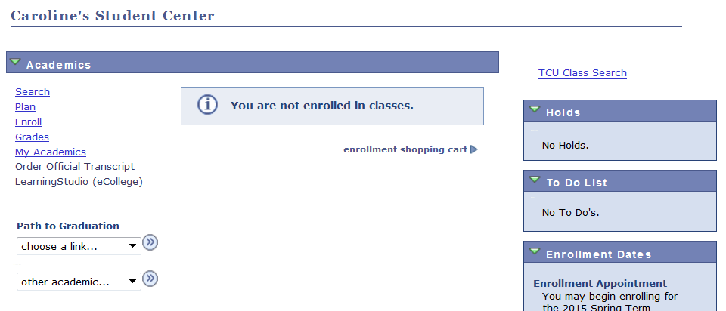

- Select the term from the dropdown. Answer the questions that follow, including a statement on the courses or requirements you want approval to take at another institution.
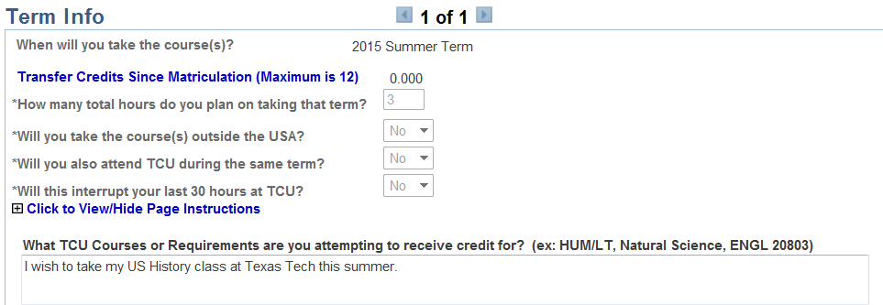

- Carefully read the Instructions and Guidelines from your college, and click the “I agree” button at the bottom.
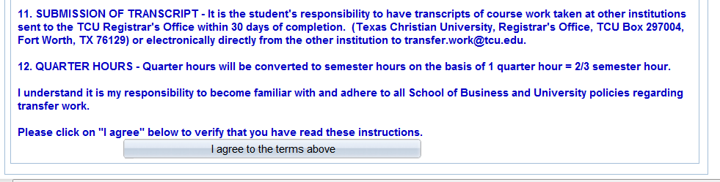

- Choose your school. You may search by school name,
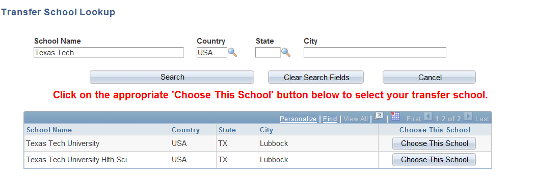
- or by City & State
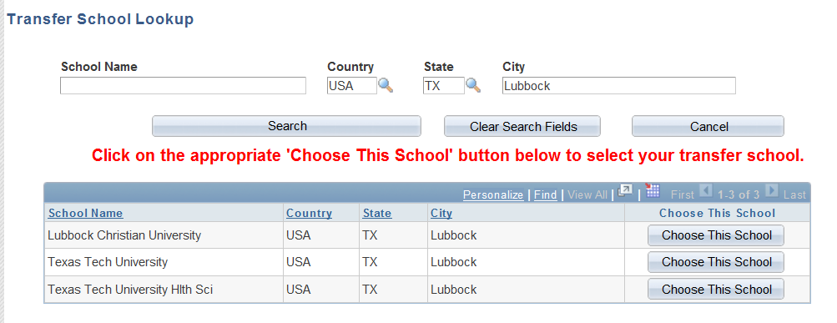
- Use the lookup for both the School Subject and School Course Nbr. If you cannot find your courses, you may enter the information.
- If needed, enter the course title. Paste in the course description, and answer the remaining questions.
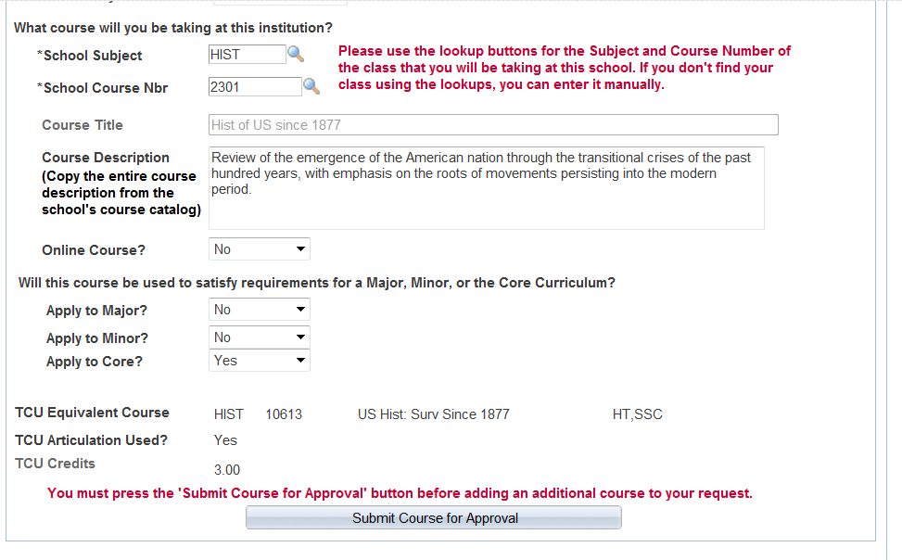
- Click on the “Submit Course for Approval” button. When you have successfully completed the request, you will see this message.
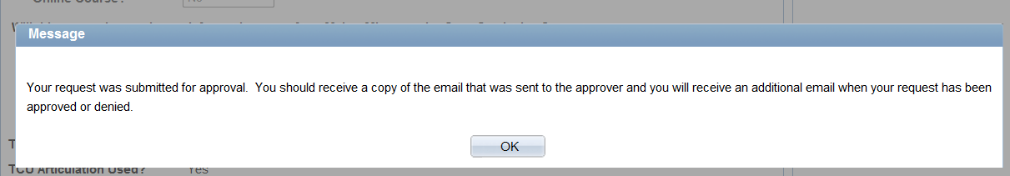

- You will also receive the email below. This email will also be sent to the first approver. You may return to this email, and click on the Student Link to check the status or your request.
Please review the Transfer Credit Request for Susan Student (123456789) and either Approve or Deny the request.
Term - 2015 Summer Term
School - Texas Tech University
Class - HIST 2301
Approved as TCU equivalent course - HIST 10613 US Hist: Surv Since 1877
You may return to your email, and use the link below at any time to check the status of this request. Students will be notified by email when the request is fully approved.
Notes From Susan Student:
I wish to take my US History class at Texas Tech this summer.
You must sign in to my.tcu.edu here before clicking on the link below:
- Approver: Click Here To Approve This Request
- Student: Click Here To Review Your Request

- When your dean’s office has made the final approval, you will receive an email that your request was approved.

- After you have completed your course, request that a transcript to be sent to the Registrar’s Office. You will be notified when your transcript has been received by the Registrar’s Office, and again when your credits have been posted.

